Term | Definition | Image
Resistor | Used to resist the flow of current or to control the voltage in a circuit. Measured in Ohms. | 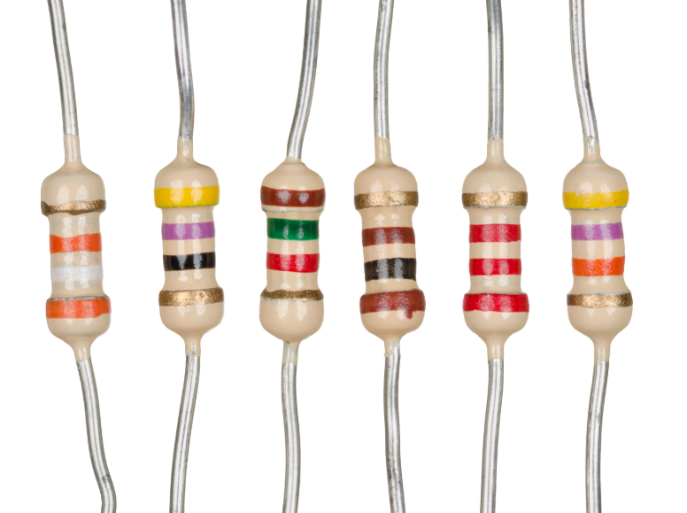
Potentiometer | When you turn the shaft of this device, the resistance changes in the circuit - also known as a variable resistor. These components can be found in devices such as a light dimmer or volume control for a radio. | 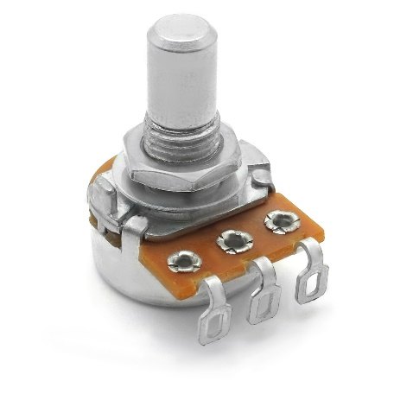
Photocell | Also called a light-dependent resistor - its resistance changes with the intensity of the light. Often found in exterior lights that automatically turn on at dusk and off at dawn. | 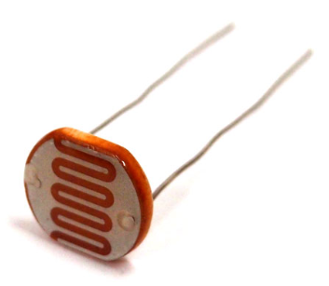
Capacitor | This stores electricity and then will discharge it back into the circuit when there is a drop in voltage. This is like a rechargeable battery and can be charged and then discharged. | 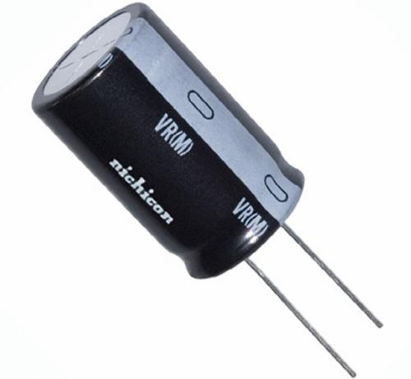
Diode | Allows electricity to flow in one direction and blocks it from flowing the opposite way. This acts as a "one-way" street. Its primary role is to route electricity from taking an unwanted path within the circuit. | 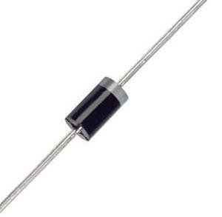
Light-Emitting Diode (LED) | Emits light when electricity flows through it. Is like a standard diode in the fact that electrical current only flows in one direction. | 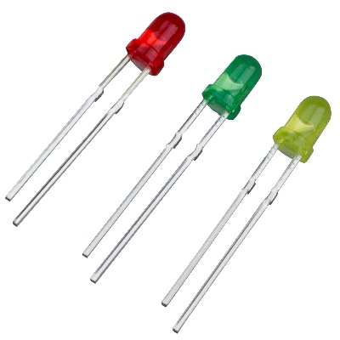
Transistor | Tiny switch that turn a current on or off when triggered by an electric signal. It can also be used to amplify electronic signals. | 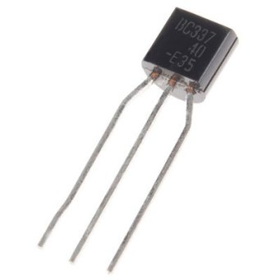
555 Timer IC | A circuit that’s been reduced in size to fit inside a tiny chip. This circuit contains electronic components like resistors and capacitors but on a much smaller scale. Each pin on an IC is unique in terms of its function. | 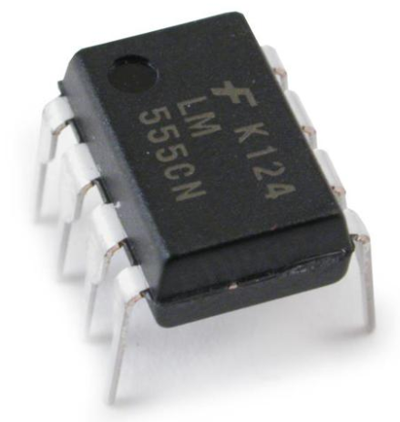
Switch | Basic function is to interrupt electric current by turning a circuit on or off. | 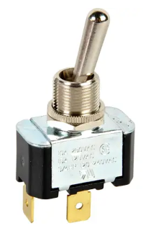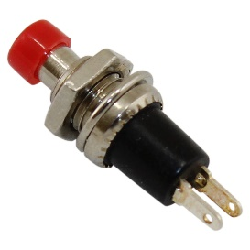
Electric Motor | An electrical machine that converts electrical energy into mechanical energy - can be powered by DC or AC. | 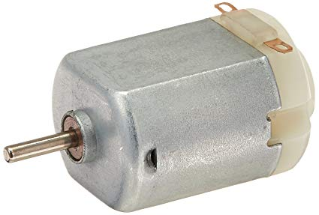
Breadboard | An essential tool for prototyping and building temporary circuits - they contain holes for inserting wire and components - they allow you to create circuits without soldering. | 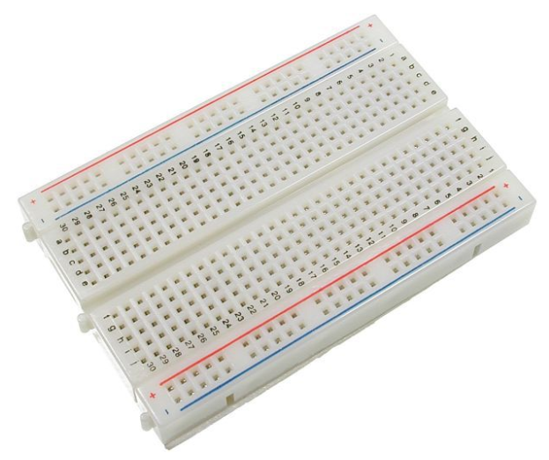
Digital Multimeter | A device that’s used to measure electric current (amps), voltage (volts) and resistance (ohms). It’s a great tool for troubleshooting circuits and is capable of measuring both AC and DC voltage. | 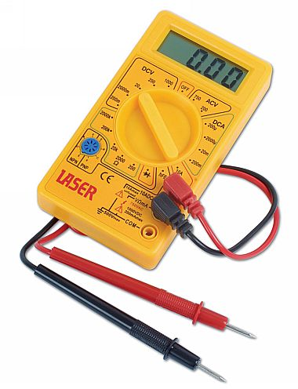
Battery Snap | Designed to snap onto the leads on the terminal end of any standard 9V battery. These battery straps have two leads - a red "positive" wire and a black "negative" wire. | 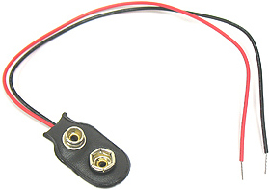
Alligator Clips | Also called "Test Leads" - great for connecting components together to test a circuit without the need for soldering. | 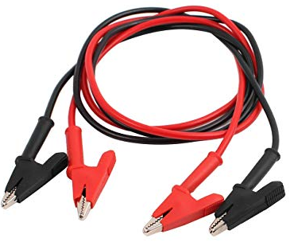
Wire Cutters | A tool used for stripping stranded and solid copper wire. | 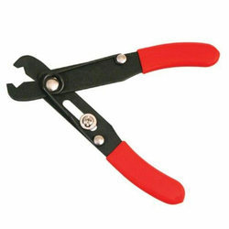
Jumper Wires | Used with breadboards to make connections and are usually made of thin, shorter, solid core wire. | 